Riphah International University
Gulberg Green Campus Islamabad
Faculty of Computing (WISH)



Name: Anisha Rehmat.
Sap ID: 78019.
Submitted To: Mam Nayab Khalid
Submitted by: Anisha Rehmat.

Supervision and Coordination

Miss Hira Jafar
Lecturer
Faculty of Computing

Lab Designers

Miss Nayab Khalid
Teaching Fellow
Faculty of Computing

Lab Task 9

Introduction:-
Abstraction is the process of simplifying complex systems by focusing on essential details while hiding unnecessary ones. In object-oriented programming, it helps manage complexity by exposing only relevant functionalities. This promotes cleaner, more maintainable, and modular code.

Concept Map:-
• What are Abstract Classes
• Abstract Methods
• Interface (Multiple Inheritance)
• Lab Exercise and Demo

Lab Tasks

Task 1:
You are tasked with designing a transportation system using Object-Oriented Programming (OOP) principles in Java.
1. Abstract Class: Transport
o Define an abstract method move() to represent the movement behavior of different transport types. o Define a concrete method fuelType() that prints "Uses fuel or electricity."
2. Concrete Subclasses:
o Create a subclass Train that extends Transport:
▪ Implement the move() method to print "Train runs on tracks." o Create another subclass Airplane that extends Transport:
▪ Implement the move() method to print "Airplane flies in the sky."
3. Main Method:
o In the Main class:
▪ Create polymorphic references of type Transport for both Train and Airplane.
▪ Call move() and fuelType() methods for each object to demonstrate polymorphism and method overriding.

Code:-
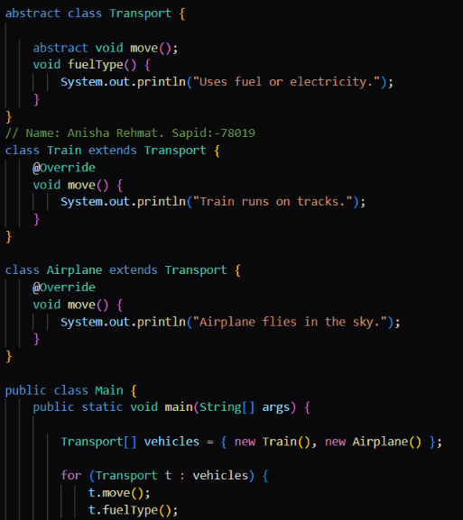
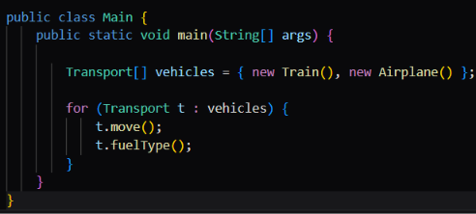
Output:-
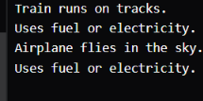

Task 2:
Create an interface named PaymentGateway:
• Declare a method makePayment(double amount).
Implement at least three payment types as classes:
• CreditCardPayment
• PayPalPayment
• UPIPayment
• Each class should implement PaymentGateway and define custom logic for makePayment() (e.g., print a message showing which payment is being processed).
Create a Main class to test your implementation:
• Use polymorphism by referencing PaymentGateway while creating objects of the specific payment classes.
• Call the makePayment() method for each payment type using different objects.

Code:-
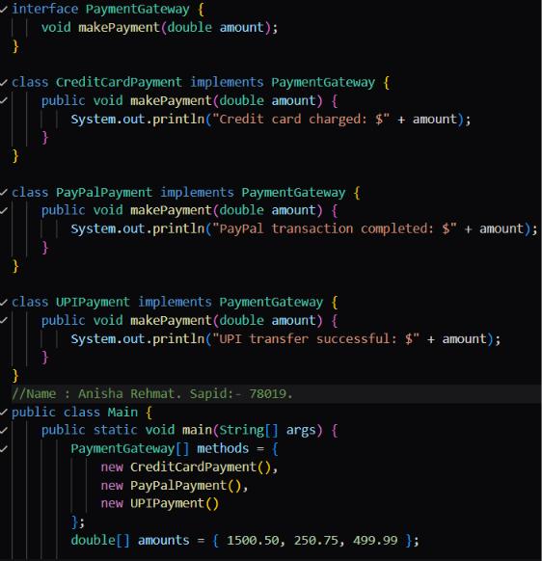

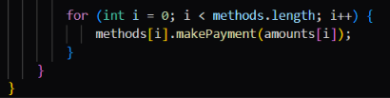
Output:-


